Web Technology

Lab - 4

Name - Eishaan Khatri

Roll No. - 22mc3014

T1)

Create a webpage that has a heading and a button. Write a script to change the

background colour and text when the button is clicked.

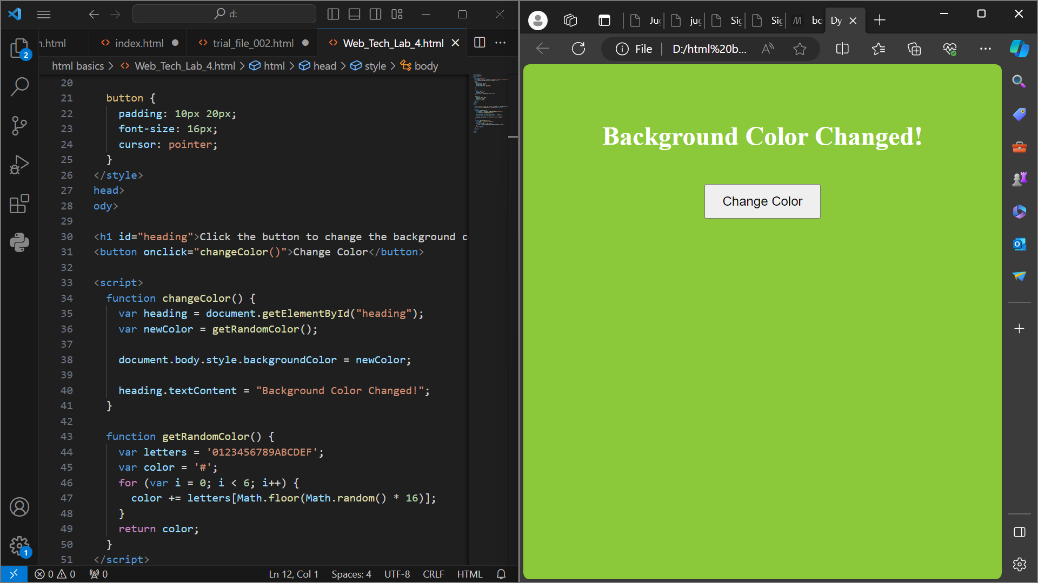

T2. For T1, experiment with the Javascript code by trying the following things:

a. Make the background light green.

b. Add a line that makes the text red.

c. Change the font size to 48pt.

d. Change the wording inside the <h1> tag in the Javascript.

e. Add <button>Click Me</button> after the closing </h1>.

**<!DOCTYPE html>**

**<html lang="en">**

**<head>**

**<meta charset="UTF-8">**

**<meta name="viewport" content="width=device-width, initial-scale=1.0">**

**<title>LAB 4</title>**

**<style>**

**body {**

**font-family: Arial, sans-serif;**

**text-align: center;**

**padding: 20px;**

**}**

**h1 {**

**color: #333;**

**}**

**#changeButton {**

**padding: 10px 20px;**

**font-size: 16px;**

**cursor: pointer;**

**}**

**</style>**

**</head>**

**<body>**

**<h1 id="heading">Click the button to change color!</h1>**

**<button id="changeButton" onclick="changeColor()">Change Color</button>**

**<script>**

**function changeColor() {**

**var heading = document.getElementById("heading");**

**var button = document.getElementById("changeButton");**

**// Change background color to light green**

**heading.style.backgroundColor = 'lightgreen';**

**// Change text color to red**

**heading.style.color = 'red';**

**// Change font size to 48pt**

**heading.style.fontSize = '48pt';**

**// Change the wording inside the <h1> tag**

**heading.textContent = "Color and Text Changed!";**

**// Add a new button after the heading**

**var newButton = document.createElement("button");**

**newButton.textContent = "Click Me";**

**document.body.appendChild(newButton);**

**}**

**</script>**

**</body>**

**</html>**

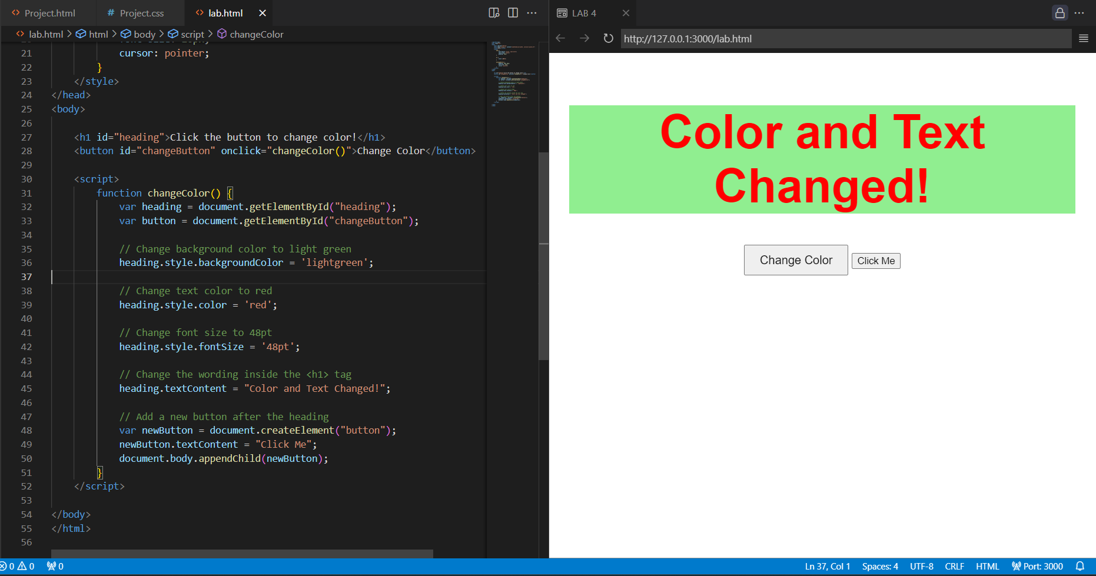

### **T3. For T1, set the color of the background directly with the class attribute. Generate alerts before and after assigning the class attribute to document object.**

**<!DOCTYPE html>**

**<html lang="en">**

**<head>**

**<meta charset="UTF-8">**

**<meta name="viewport" content="width=device-width, initial-scale=1.0">**

**<title>LAB 4</title>**

**<style>**

**body {**

**font-family: Arial, sans-serif;**

**text-align: center;**

**padding: 20px;**

**}**

**.lightGreenBackground {**

**background-color: lightgreen;**

**}**

**h1 {**

**color: #333;**

**}**

**#changeButton {**

**padding: 10px 20px;**

**font-size: 16px;**

**cursor: pointer;**

**}**

**</style>**

**</head>**

**<body>**

**<h1 id="heading">Click the button to change color!</h1>**

**<button id="changeButton" onclick="changeColor()">Change Color</button>**

**<script>**

**function changeColor() {**

**var heading = document.getElementById("heading");**

**var button = document.getElementById("changeButton");**

**// Alert before assigning the class**

**alert("Before assigning class: Background color will be changed.");**

**// Assign the class to change the background color**

**heading.classList.add("lightGreenBackground");**

**alert("After assigning class: Background color changed.");**

**}**

**</script>**

**</body>**

**</html>**

### 

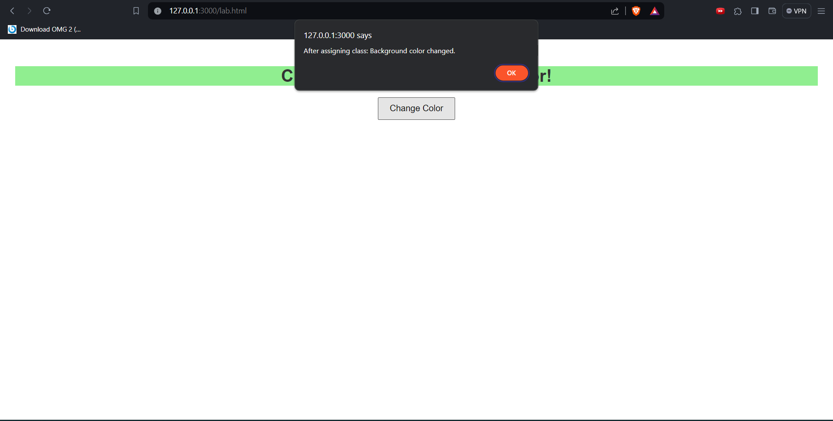

### **T4. Design a page having contents within and outside the main section. The page must contain a button that when clicked replaces the content of the main section with another content having different style.**

**<!DOCTYPE html>**

**<html lang="en">**

**<head>**

**<meta charset="UTF-8">**

**<meta name="viewport" content="width=device-width, initial-scale=1.0">**

**<title>LAB 4</title>**

**<style>**

**body {**

**font-family: Arial, sans-serif;**

**text-align: center;**

**padding: 20px;**

**}**

**main {**

**border: 2px solid #333;**

**padding: 20px;**

**margin: 20px;**

**}**

**#changeButton {**

**padding: 10px 20px;**

**font-size: 16px;**

**cursor: pointer;**

**}**

**.newContent {**

**color: red;**

**font-size: 24px;**

**font-weight: bold;**

**}**

**</style>**

**</head>**

**<body>**

**<header>**

**<h1>Webpage with Content Replacement</h1>**

**</header>**

**<main id="mainSection">**

**<p>This is the initial content of the main section.</p>**

**</main>**

**<button id="changeButton" onclick="replaceContent()">Replace Content</button>**

**<footer>**

**<p>Footer content outside the main section.</p>**

**</footer>**

**<script>**

**function replaceContent() {**

**var mainSection = document.getElementById("mainSection");**

**// Create new content**

**var newContent = document.createElement("p");**

**newContent.textContent = "This is the new content with a different style.";**

**newContent.classList.add("newContent");**

**// Replace existing content with the new content**

**mainSection.innerHTML = ""; // Clear existing content**

**mainSection.appendChild(newContent);**

**}**

**</script>**

**</body>**

**</html>**

### 

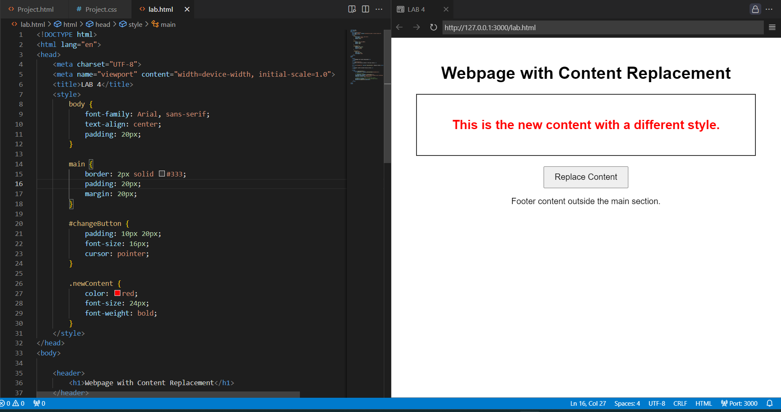

### **T5. Consider a h1 heading lying outside the main section in the page. Try changing the color of h1 in at least 3 different ways.**

**<!DOCTYPE html>**

**<html lang="en">**

**<head>**

**<meta charset="UTF-8">**

**<meta name="viewport" content="width=device-width, initial-scale=1.0">**

**<title>LAB 4</title>**

**<style>**

**body {**

**font-family: Arial, sans-serif;**

**text-align: center;**

**padding: 20px;**

**}**

**h1 {**

**margin-bottom: 20px;**

**}**

**/* Method 1: Using a specific color */**

**.method1 {**

**color: red;**

**}**

**/* Method 2: Using hexadecimal color code */**

**.method2 {**

**color: #00ff00; /* Green color */**

**}**

**/* Method 3: Using RGB color values */**

**.method3 {**

**color: rgb(0, 0, 255); /* Blue color */**

**}**

**</style>**

**</head>**

**<body>**

**<h1 class="method1">Heading with Color (Method 1)</h1>**

**<h1 class="method2">Heading with Color (Method 2)</h1>**

**<h1 class="method3">Heading with Color (Method 3)</h1>**

**</body>**

**</html>**

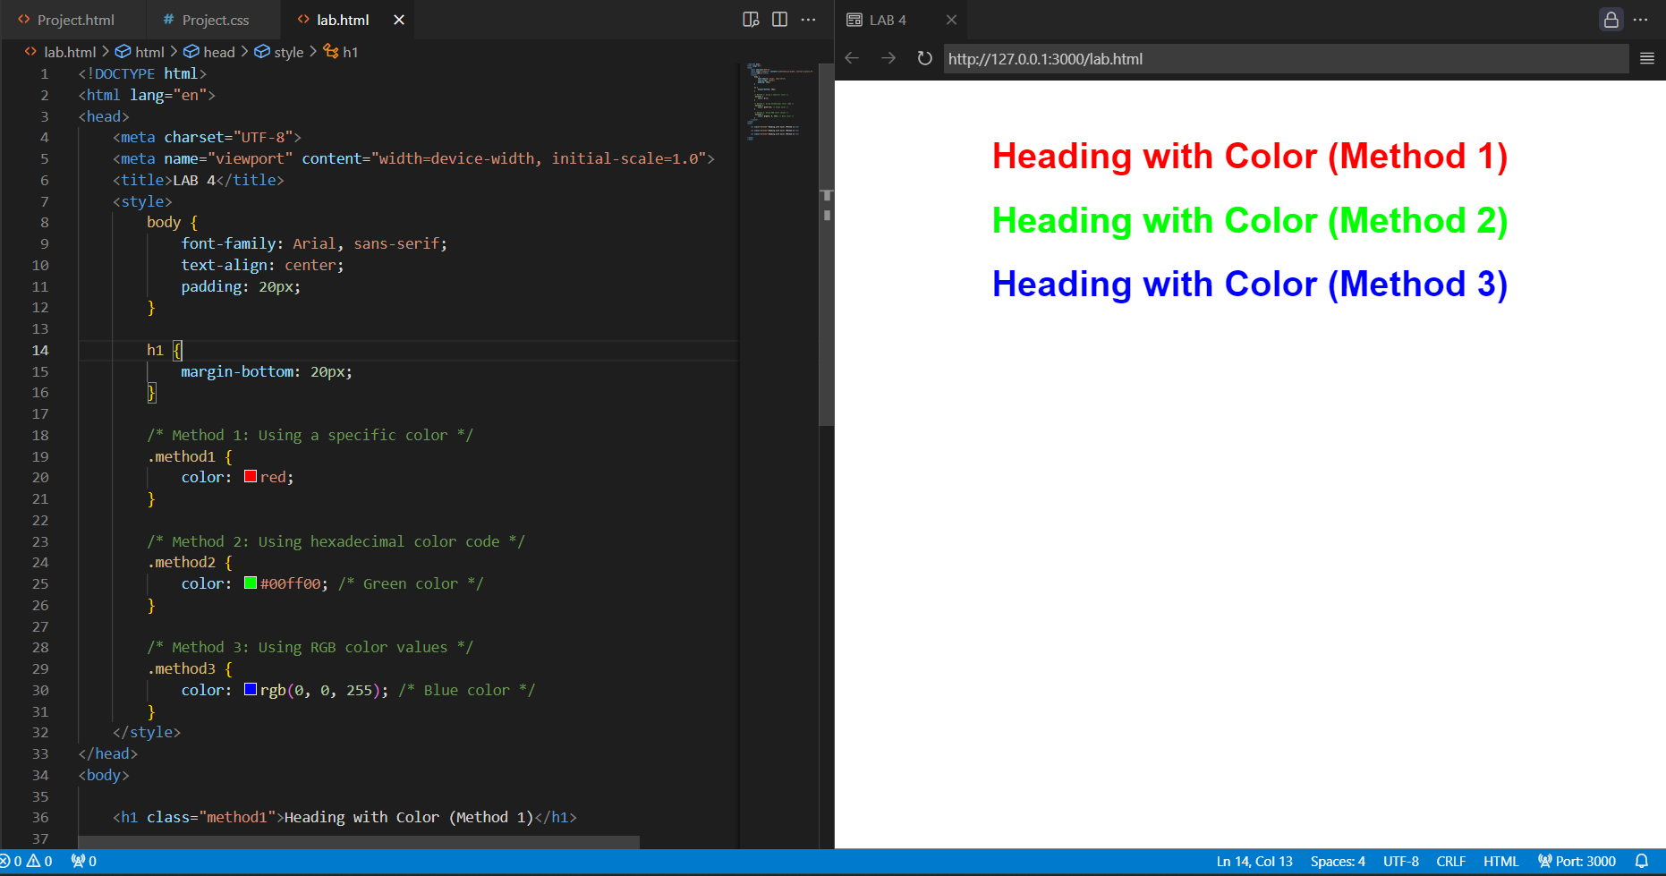

### **T6. Design a webpage using grid layout that displays the following:**

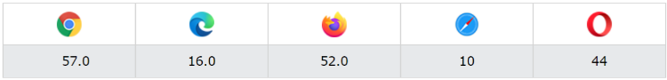

### **The first row shows icons of various web browsers and the second row shows the latest version number.**

**<!DOCTYPE html>**

**<html lang="en">**

**<head>**

**<meta charset="UTF-8">**

**<meta name="viewport" content="width=device-width, initial-scale=1.0">**

**<title>LAB 4</title>**

**<style>**

**body {**

**font-family: Arial, sans-serif;**

**margin: 0;**

**padding: 0;**

**}**

**.grid-container {**

**display: grid;**

**grid-template-rows: auto auto; /* Two rows with auto height */**

**grid-template-columns: repeat(5, 1fr); /* Five columns with equal width */**

**gap: 10px; /* Gap between grid items */**

**padding: 20px; /* Padding around the grid */**

**}**

**.grid-item {**

**text-align: center;**

**}**

**.grid-item img {**

**max-width: 100px; /* Limit maximum width of the icons */**

**}**

**</style>**

**</head>**

**<body>**

**<div class="grid-container">**

**<!-- First row: Icons of various web browsers -->**

**<div class="grid-item"><img src="chrome.png" alt="Chrome"><p>Chrome</p></div>**

**<div class="grid-item"><img src="edge.png" alt="Edge"><p>Edge</p></div>**

**<div class="grid-item"><img src="firefox.png" alt="Firefox"><p>Firefox</p></div>**

**<div class="grid-item"><img src="safari.webp" alt="Safari"><p>Safari</p></div>**

**<div class="grid-item"><img src="opera.png" alt="Opera"><p>Opera</p></div>**

**<!-- Second row: Latest version numbers -->**

**<div class="grid-item">57.0</div>**

**<div class="grid-item">16.0</div>**

**<div class="grid-item">52.0</div>**

**<div class="grid-item">10</div>**

**<div class="grid-item">44</div>**

**</div>**

**</body>**

**</html>**

### 